**Bats say: Let California burn**

Derek Corcoran1, Lisa Webb1, Dylan Kesler2.

1 University of Missouri, Department of Fisheries and Wildlife 302 Anheuser-Busch Natural Resources Bldg, Columbia, MO 65211, USA

2 Institute of Bird Population 11435 CA-1 Suite 23, Point Reyes Station, CA 94956, USA

Corresponding Author: Derek Corcoran corcoranbarriosd@missouri.edu

**Abstract**

Increasing wildfire frequency in Western United States makes it increasingly important to understand the effects of fire mediated habitat changes on biodiversity. We evaluated effects of wildfire on occupancy for 17 species of bats in areas recently burned in the Sierra Nevada Mountains. During 2015 and 2016, we used Pettersson D500X passive detectors to record bat species for three consecutive nights at “50” sites. We used k-means to classify the forest environment into five habitat types (based on altitude, distance to water, distance to road, and vegetation type), and assigned five sites for each habitat type randomly within wildfire areas and five sites outside wildfire areas. Occupancy models were structured with all possible linear combinations of five variables associated with fire intensity, and ranked using an information theoretic approach. Our results indicate that 13 out of the 17 (This will change) species have higher average occupancy in burned vs unburned areas, including three species of conservation concern, showing a positive relationship between fire intensity and occupancy.

**Introduction**

Recent studies have shown that there has been an increase in both fire frequency and severity in western North America, and in the Sierra Nevada Mountain Range in particular (Miller et al., 2009; Westerling et al., 2006)(Fig 1). The increase in the fire frequency is due both to human activity (Syphard et al., 2007) and global change (Lenihan et al., 2003). Predictions indicate that fires in the western region will increase in frequency and area through year 2100 (Liu and Wimberly, 2016). An evaluation of fire intensity and frequency since 1970 in western United States shows that more than 75% of the fires that have with intensities greater than the average intensity of the western United States region , correspond to wildfires in either Sierra Nevada or the Rocky Mountains (Westerling et al., 2006).

In the Northern Sierra Nevada Mountains, natural forests historically had a higher representation of fire tolerant species due to a natural regimen of high frequency, low intensity fire (Covington, 2000). However, recent fire suppression has led to fuel accumulations that are associated with higher intensity fires. The lack of recent low intensity fires also has resulted in higher representations of fire intolerant species (Beaty and Taylor, 2008). Despite already elevated fire occurrence, fires will likely continue to increase in frequency and area through year 2100 (Liu and Wimberly, 2016). For example modeling of temperatures and precipitation, taking into account wind speeds and relative humidity, have indicated increases in future fire potential and the length of future wildfire seasons (Liu et al., 2013). Specifically in Sierra Nevada, an increase in frequency of uncontrolled (escape) fires of 125% and a 41% increase in burned area (Fried et al., 2004). More recent studies, have shown that large fires (over 5000 Ha), will have the largest increase in number in the Sierra Nevada range and Northern Rockies (Barbero et al., 2015). Simulations with four different scenarios of global change, taking into account temperature and precipitation changes, show that the highest increase in wildlife fires would happen in the Sierra Nevada area of California (Westerling and Bryant, 2008; Miller et al., 2009). Higher elevations appear to be at particularly heightened risk (Keeley and Syphard, 2015; Schwartz et al., 2015)

Despite the vast number of studies that show that the Sierra Nevada is and will be one of the ecosystems that will have a higher increase in fire regiment, there are not many studies about the effects of these on the native fauna. Studies of fire impacts conducted in prescribed fire areas in the foothills of the Sierra Nevada indicated that the effect of fire in bird and mammal abundance is species-specific (Converse et al., 2006; Seavy et al., 2008). Whereas some species responded to fire intensity, others responded to heterogeneity in the post-fire environment (Roberts et al., 2008). Other investigations indicated no influence of prescribed fires on small mammal or songbird diversity measured as shannon's diversity index, but a decline of spotted owl use (Stephens et al., 2014). Arthropods have also been shown to respond to wildfires and prescribed fires, although changes in community composition were highly variable (Apigian et al., 2006). Clearly, understand the impact of high intensity fires in the forested systems of western North America is paramount and more work is needed.

More than 950 bat species comprise approximately 20% of all mammals species, second only to rodents (Hill, 1984; Wund and Myers, 1991; Mayer et al., 2007). Most of the chiropterans depend on forests for a portion of their life cycle (Miller et al., 2003), and 25 of the 45 North American species of bats use forest either for foraging or roosting (Faure et al., 1993; Faure and Barclay, 1992; O’Shea and Bogan, 2003). Of the tree-roosting bats, a wide range of roost sites are used, with some species illustrating a preference for snags and others for foliage sites, but many preferring older growth stands (Hutchinson and Lacki, 2000; Veilleux and Veilleux, 2004; Kalcounis-Rüppell et al., 2005). Similarly, bats forage in a diverse array of microenvironments and they specialize on particular prey items. All of these resources may be differentially affected by fire

Bats are a group of conservation concern, the International Union for the Conservation of Nature (IUCN; Gland Switzerland) indicates that 22% of the microchiroptera are either extint, critically endangered, endangered or vulnerable (Hutson and Micklebrugh, 2001). Globally, habitat fragmentation, habitat lost, destruction of roost sites, use of insecticides are among the greatest threats to bats (Jefferies, 1972; Jones et al., 2009). And within North America, the recent emergence of white nose syndrome poses a further, and potentially much greater, specter. Since white noes syndrome was discovered in a winter hibernaculum in New York in 2006 it has spread to 25 US states and 5 Canadian provinces (USGS) killing over 5 million bats (Leopardi et al., 2015).

Global change also poises a major threat to bats, in temperate regions their reproductive cycle is linked with their hibernation which is also triggered by temperature. Thus hibernation can cause bats to emerge earlier than they should affecting not only their reproductive cycle but also food availability (Jones et al., 2009). Climate change may also affect bat ranges, the ranges of their food items, but also fire regimes that may reduce roost site availability (Sherwin et al., 2013).

Some have questioned the potential impacts of fire, fire frequencies, and fire intensity on bat occupancy and occurrence. So far the response of bats to the change in the fire regime has been limited. The only works that research the response of bats to fire divides the environments in high and low intensity fires (Buchalski et al., 2013), but the response of this taxonomic group to fire is probably more complex than that, since understory fires increases the availability of insects (Lacki et al., 2009), which would be positive for bats, but high intensity basal fire reduce roosting sites for bark dwelling bats, and canopy fires diminishes roosting sites for folliage roosting bats such as the Hoary bats, and increases roosting sites for bark and cavity roosting bats (Klug et al., 2012; Kunz et al., 2003). Thus we would expect high intensity fires to favor bat occupancy of bark and cavity roosting bats, and no or low intensity fires to increase occupancy in foliage roosting bats. Due to this complex relationship between microchiroptera and fire, we study the effect of soil, basal and canopy burn intensity coupled with distance to fire edge and distance to unburned forest to elucidate the effects of different fire regimes in an ensemble of 17 bat species including three Forest Service declared sensitive species.

**Methods**

*Study site*

The research took place in Plumas National Forest (40°00′01″N 120°40′05″W). In the Sierra Nevada mountain Range in Northern California. This national forest comprises 463,769.75 hectares and it has a recent history of large wildfires. The moonlight wildfire (2007) burned 26,303.35 hectares, the Storrie fire (2000) burned 21,043.65 and the rich fire (2008) burned 2,468.58 hectares. The altitude range for this national forest goes from 311 to 2433 meters above sea level with a mean of 1555 . According to the Western Regional Climate Center the average annual rainfall is 1019.9 mm, the average high of and low of the warmest months are 31.9 and 6.7 degrees Celsius respectively and the average high and low for the coldest month are 7.4 and -4.7 degrees Celsius.

The Sierra Nevada Bioregion is dominated by mixed-conifer forest with some redwood forest and evergreen conifer areas (Steel et al., 2015) and a fuel-limited fire regimes (Steel et al., 2015). It has a Mediterranean climate with dry and warm summers and cool wet winters. The highest precipitation in the state of California corresponds to our study site in the northern limit of the Sierra Nevada (van Wagtendonk and Fites-Kaufman, 2006). Changes in the ecosystems and communities along the Sierra Nevada mainly follow a west-east gradient of altitude and rainfall due to orographic rains coming from the pacific coast, rainfall increases with altitude and as it drops to the east we find the driest environments. The most common environment is the lower montane forest (van Wagtendonk and Fites-Kaufman, 2006). The dominant species of this community are the Jeffrey Pine (*Pinus jeffreyi*) and Ponderosa Pine (*Pinus ponderosa*)

*Site selection*

In order to get most of the variability of the sampling sites we used GIS information provided by the forest service (Roads, Bodies of water, fire intervals and vegetation type), together with the Gebco altitude database, and made a raster stack with the following layers (distance to road, distance to water, mean fire interval in years, vegetation type and altitude). This was used to classify sampling area into 5 different environments to capture most of the heterogeneity of the site, to ensure access to the site we eliminated all areas with over 15% of slope, which eliminated 7.8% of the sampling area.

Ten random points where selected from each environment type, five from the fire affected areas and five from the non fire affected areas.

*Sampling*

The sampling took place from June the 8th of 2015 and July 31 of the same year. Pettersson D 500x bat detectors where deployed in each sampling point for three days recording from 7:30 pm to 6:30 pm, thus ensuring equal sampling effort. The recorded calls where passed through the Sonobat Software to develop the detection histories.

*Variables*

For the probability of detection part of the models iButton DS1923-F5 data loggers were used to record humidity and temperature every hour. Then the mean, standard deviation, minimum and maximum temperature and humidity were calculated for the sampling period were used as variables, together with the Julian date. All this variables were scaled and centered using the caret package.

For the occupancy part of the model, we used three measurements of vegetation burn severity to capture the intensity of the fire in the different structural parts of the fire that may affect the bats selection or performance in an environment, for this we used teledetection GIS layer from the forest service that capture vegetation burn severity calibrated to percent change in canopy cover and basal area for fires in pacific southwest region national forests, plus soil burn severity by using Landsat imagery (Miller and Quayle, 2015). This variables where: *Burn intensity basal*; where 0 is equivalent to 0% change, 1 is equal to change more than 0 and less than 10%, 2 is equal to changes between 10 and 25%, 3 is change between 25% and 50%, 4 is changes between 50% and 75%, 5 is changes between 75% and 90% and 6 is changes over 90%. *Burn intensity canopy,* where 0 is equivalent to 0% change, 1 changes over zero and bellow 25%, 2 changes between 25% and 50%, 3 between 50% and 75%, and 4 between 75% and 100%.

*Burn intensity soil.*

We also used two variables to capture the spatial structure of the habitat in terms of fire damage, where distance to fire is the distance in meters from the unburned forest to the edge of a burned area in meters, if the sampling point was inside the burned area this distance would be zero. This variable was log transformed to better capture distance reality in biological species; and Distance to forest, which is the distance in meters from the burned forest to the edge of unburned areas in meters, if the sampling point was outside of the burned area this distance would be zero. This variable was log transformed to better capture distance reality in biological species. All this variables where scaled and centered (Bro and Smilde, 2003; Gelman and Hill, 2006).

*Analysis*

*Occupancy modeling.—*We related bat species presence to fire intensity, distance to fire and distance to the forest, using single-season occupancy models (MacKenzie et al. 2006). Occupancy models use detection-nondetection data from repeat surveys to simultaneously estimate probabilities of detection (*p*) and occupancy ($ψ$); MacKenzie et al. 2006).

All the analysis including the ones performed for the sampling design where performed using R statistical Software. Occupancy models were developed using the unmarked package, the best model was selected by AICc using the MuMin Package (Barton 2015). First the best model for probability of detection was selected by fitting all possible first order models keeping occupancy constant. Then that part of the model was fixed and the occupancy component of the model was selected on the same way by fitting all possible first order models, since all three of burn intensity measurements where highly correlated (>= 0.98 Pearson correlation coefficient), those three variables where not permitted to coexist in the tested models. The resulting model was projected for the whole National Forest for each species. The best model for each species was assessed for goodness of fit using a Person Chi square statistic (MacKenzie and Bailey, 2004).

For each species the occupancy inside and outside of the fire areas was compared by doing a t-test between the fitted values for the sampled points.

**Results**

Fourty-nine of the fifty original sites were sampled, 24 corresponding to unburned areas and 25 to burned areas (Figure 1). On 14 of the 17 species studied, the top selected model was found to fit the data in the field (Table 1), the only species where the top model was not significant were Parastrellus hesperus, Lasiurus cinereus and Euderma maculatum. Of those 14 species all but *Myotis volans,* were the null model for occupancy was selected as the top model, showed a relationship between at least one of the fire related variables and occupancy.

Of the 13 species, that whose occupancy was affected by fire, twelve of them had significantly higher occupancy values within the fire areas than outside of them, including the pallid bat, fringed myotis and Townsend long eared bat, all species of conservation concern. Only the western red bat (Lasirurs blossevillii) presenting higher occupancies in unburned forest that within the burned areas, which is interesting considering that it is a species that roosts in the tree foliage.

**Discussion**

There is a clear positive relationship between 13 of the 17 species studied in Plumas National Forest and fire intensity, which indicates that bats may not be negatively affected as other taxonomic groups by the increase of both fire intensity and frequency. There has been previous studies showing that fire suppression has a negative effect on biodiversity in particular in the rocky mountains (Keane et al., 2002; Syphard et al., 2007). There is also evidence at least for some particular groups that prescribed fires do not replicate the effect of wildfires and hence they diminish the performance of native species (Rota et al., 2014). Another effect of fire suppression is the over representation of fire intolerant species, this may only be changed without affecting species that depend on fire, by letting wildfires occur more frequently than prescribed fires (Miller et al., 2009; Stephens, 1998).

Species interaction may also be playing a role in the community of bats of Sierra Nevada. The occupancy of many of the species studied where highly correlated with each other (fig 4). This coupled with Bayesian approaches (Rota et al., 2015) may improve the quality of the models and at the same time improve our understanding of the effects of Wildfires on bats.

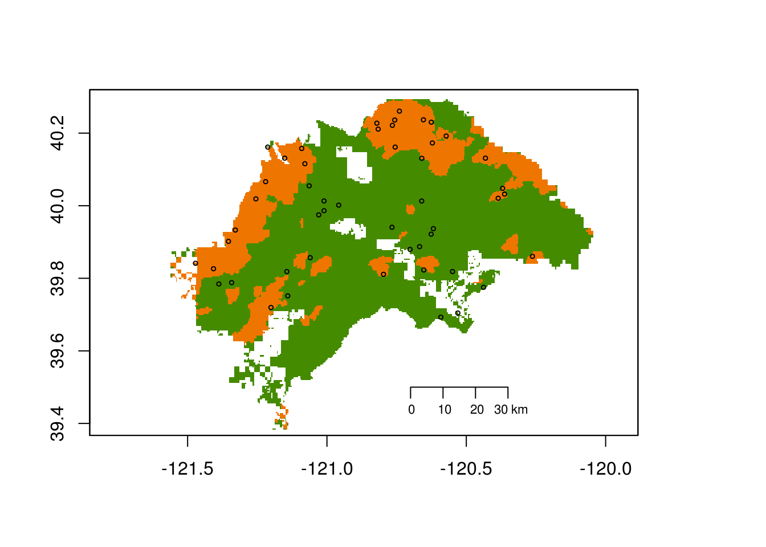

Fig 1. Map of the sampled area in Plumas National Forest and the sampled points. The burned area is shown in orange and the non-burned area in green.

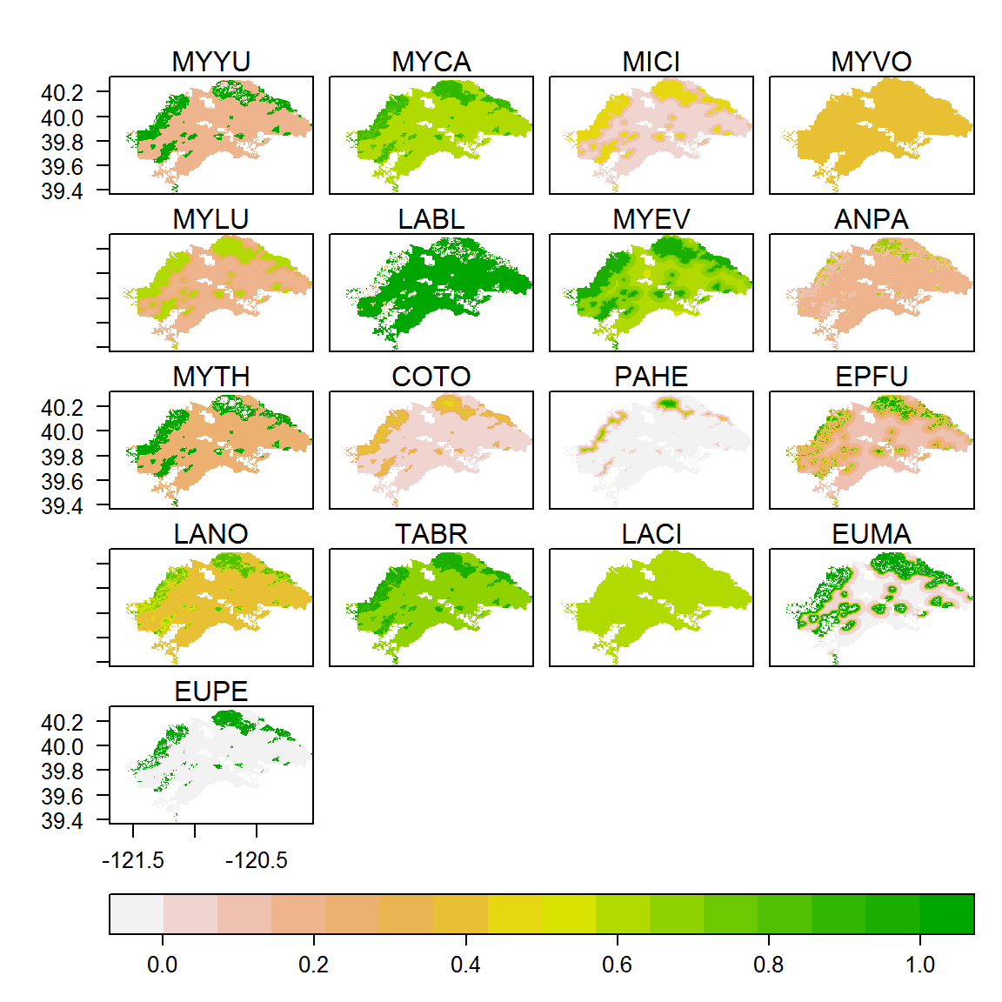

**Fig 2. Maps showing the predicted occupancy of each bat species for the whole National Forest.**

**Table 1. Goodness of fit of the best model for each species, assessed by chi square goodness of fit test, all but three species models fit the observed data, bold values of p indicate models that are significantly different than their theoretic model**



**Table 2. Comparison of means of occupancy between burned and unburned areas, bold p values show significant difference between the means, the difference is the mean occupancy on burned sampling points minus the mean occupancy in unburned sampling points**



**References**

Apigian, K.O., Dahlsten, D.L., Stephens, S.L., 2006. Fire and fire surrogate treatment effects on leaf litter arthropods in a western Sierra Nevada mixed-conifer forest. For. Ecol. Manag. 221, 110–122.

Barbero, R., Abatzoglou, J.T., Larkin, N.K., Kolden, C.A., Stocks, B., 2015. Climate change presents increased potential for very large fires in the contiguous United States. Int J Wildland Fire Doi 10, 1071.

Beaty, R.M., Taylor, A.H., 2008. Fire history and the structure and dynamics of a mixed conifer forest landscape in the northern Sierra Nevada, Lake Tahoe Basin, California, USA. For. Ecol. Manag. 255, 707–719.

Buchalski, M.R., Fontaine, J.B., Heady III, P.A., Hayes, J.P., Frick, W.F., 2013. Bat response to differing fire severity in mixed-conifer forest, California, USA. PloS One 8, e57884.

Converse, S.J., White, G.C., Farris, K.L., Zack, S., 2006. Small mammals and forest fuel reduction: national-scale responses to fire and fire surrogates. Ecol. Appl. 16, 1717–1729.

Covington, W.W., 2000. Helping western forests heal. Nature 408, 135–136.

Faure, P.A., Barclay, R.M., 1992. The sensory basis of prey detection by the long-eared bat, Myotis evotis, and the consequences for prey selection. Anim. Behav. 44, 31–39.

Faure, P.A., Fullard, J.H., Dawson, J.W., 1993. The gleaning attacks of the northern long-eared bat, Myotis septentrionalis, are relatively inaudible to moths. J. Exp. Biol. 178, 173–189.

Fried, J.S., Torn, M.S., Mills, E., 2004. The impact of climate change on wildfire severity: a regional forecast for northern California. Clim. Change 64, 169–191.

Hill, J.E., 1984. Bats: A natural history, 1st edition. ed. University of Texas Press, Adelaide.

Hutchinson, J.T., Lacki, M.J., 2000. Selection of day roosts by red bats in mixed mesophytic forests. J. Wildl. Manag. 87–94.

Hutson, A. M., & Mickleburgh, S. P., 2001. *Microchiropteran bats: global status survey and conservation action plan* (Vol. 56). IUCN.

Jefferies, D.J., 1972. Organochlorine insecticide residues in British bats and their significance. J. Zool. 166, 245–263.

Jones, G., Jacobs, D.S., Kunz, T.H., Willig, M.R., Racey, P.A., others, 2009. Carpe noctem: the importance of bats as bioindicators. Endanger. Species Res. 8, 93–115.

Kalcounis-Rüppell, M.C., Psyllakis, J.M., Brigham, R.M., 2005. Tree roost selection by bats: an empirical synthesis using meta-analysis. Wildl. Soc. Bull. 33, 1123–1132.

Keane, R.E., Ryan, K.C., Veblen, T.T., Allen, C.D., Logan, J., Hawkes, B., 2002. Cascading effects of fire exclusion in Rocky Mountain ecosystems: a literature review. USDA Forest Service, Rocky Mt. Res. Stn Gen Tech Rep GTR-91.

Keeley, J.E., Syphard, A.D., 2015. Different fire–climate relationships on forested and non-forested landscapes in the Sierra Nevada ecoregion. Int. J. Wildland Fire 24, 27–36.

Klug, B.J., Goldsmith, D.A., Barclay, R.M.R., 2012. Roost selection by the solitary, foliage-roosting hoary bat (Lasiurus cinereus) during lactation. Can. J. Zool. 90, 329–336. doi:10.1139/z11-139

Kunz, T.H., Lumsden, L.F., Kunz, T.H., Fenton, M.B., 2003. Ecology of cavity and foliage roosting bats. Bat Ecol. 1, 3–89.

Lacki, M.J., Cox, D.R., Dodd, L.E., Dickinson, M.B., 2009. Response of northern bats (Myotis septentrionalis) to prescribed fires in eastern Kentucky forests. J. Mammal. 90, 1165–1175.

Lenihan, J.M., Drapek, R., Bachelet, D., Neilson, R.P., 2003. Climate change effects on vegetation distribution, carbon, and fire in California. Ecol. Appl. 13, 1667–1681.

Leopardi, S., Blake, D., Puechmaille, S.J., 2015. White-Nose Syndrome fungus introduced from Europe to North America. Curr. Biol. 25, R217–R219.

Liu, Y., Goodrick, S.L., Stanturf, J.A., 2013. Future US wildfire potential trends projected using a dynamically downscaled climate change scenario. For. Ecol. Manag. 294, 120–135.

Liu, Z., Wimberly, M.C., 2016. Direct and indirect effects of climate change on projected future fire regimes in the western United States. Sci. Total Environ. 542, Part A, 65–75. doi:10.1016/j.scitotenv.2015.10.093

Mayer, F., Dietz, C., Kiefer, A., 2007. Molecular species identification boosts bat diversity. Front. Zool. 4, 5.

Miller, D.A., Arnett, E.B., Lacki, M.J., 2003. Habitat management for forest-roosting bats of North America: a critical review of habitat studies. Wildl. Soc. Bull. 31, 30–44.

Miller, J.D., Safford, H.D., Crimmins, M., Thode, A.E., 2009. Quantitative evidence for increasing forest fire severity in the Sierra Nevada and southern Cascade Mountains, California and Nevada, USA. Ecosystems 12, 16–32.

O’Shea, T.J., Bogan, M.A., 2003. Monitoring trends in bat populations of the United States and territories: problems and prospects. Publ. US Geol. Surv. 16.

Roberts, S.L., Van Wagtendonk, J.W., Miles, A.K., Kelt, D.A., Lutz, J.A., 2008. Modeling the effects of fire severity and spatial complexity on small mammals in Yosemite National Park, California. Fire Ecology 4 (2): 83-104. Fire Ecol. Spec. Issue Vol 4, 84.

Rota, C.T., Millspaugh, J.J., Rumble, M.A., Lehman, C.P., Kesler, D.C., 2014. The role of wildfire, prescribed fire, and mountain pine beetle infestations on the population dynamics of black-backed woodpeckers in the black hills, South dakota. PloS One 9, e94700.

Rota, C.T., Wikle, C.K., Kays, R.W., Forrester, T.D., McShea, W.J., Parsons, A.W., Millspaugh, J.J., 2015. A two-species occupancy model accommodating simultaneous spatial and interspecific dependence. Ecology.

Schwartz, M.W., Butt, N., Dolanc, C.R., Holguin, A., Moritz, M.A., North, M.P., Safford, H.D., Stephenson, N.L., Thorne, J.H., van Mantgem, P.J., 2015. Increasing elevation of fire in the Sierra Nevada and implications for forest change. Ecosphere 6, art121.

Seavy, N.E., Alexander, J.D., Hosten, P.E., 2008. Bird community composition after mechanical mastication fuel treatments in southwest Oregon oak woodland and chaparral. For. Ecol. Manag. 256, 774–778.

Sherwin, H.A., Montgomery, W.I., Lundy, M.G., 2013. The impact and implications of climate change for bats. Mammal Rev. 43, 171–182.

Steel, Z.L., Safford, H.D., Viers, J.H., 2015. The fire frequency-severity relationship and the legacy of fire suppression in California forests. Ecosphere 6, art8. doi:10.1890/ES14-00224.1

Stephens, S.L., 1998. Evaluation of the effects of silvicultural and fuels treatments on potential fire behaviour in Sierra Nevada mixed-conifer forests. For. Ecol. Manag. 105, 21–35.

Stephens, S.L., Bigelow, S.W., Burnett, R.D., Collins, B.M., Gallagher, C.V., Keane, J., Kelt, D.A., North, M.P., Roberts, L.J., Stine, P.A., others, 2014. California spotted owl, songbird, and small mammal responses to landscape fuel treatments. BioScience biu137.

Syphard, A.D., Radeloff, V.C., Keeley, J.E., Hawbaker, T.J., Clayton, M.K., Stewart, S.I., Hammer, R.B., 2007. Human influence on California fire regimes. Ecol. Appl. 17, 1388–1402.

van Wagtendonk, J.W., Fites-Kaufman, J., 2006. Sierra Nevada bioregion. Fire California’s Ecosyst. Univ. Calif. Press Berkeley Calif. USA 264–294.

Veilleux, J.P., Veilleux, S.L., 2004. Intra-annual and interannual fidelity to summer roost areas by female eastern pipistrelles, Pipistrellus subflavus. Am. Midl. Nat. 152, 196–200.

Westerling, A.L., Bryant, B.P., 2008. Climate change and wildfire in California. Clim. Change 87, 231–249.

Westerling, A.L., Hidalgo, H.G., Cayan, D.R., Swetnam, T.W., 2006. Warming and earlier spring increase western US forest wildfire activity. science 313, 940–943.

Wund, M., Myers, P., n.d. Order Chiroptera.